5.18

Friday, May 18, 2018

Prices entered into percentiletrader twice and produced 2 orders.

Not acceptable.

There should be a lock on this method.

Once a process is using a method other methods are not allowed to use it.

Whole ptf:

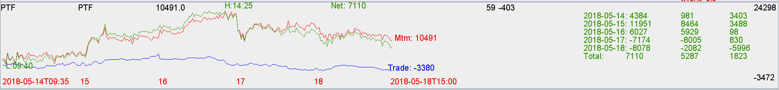

Stocks:

+19k on mtm

Futs:

Trade -3.3k.

Solution:

Put off inventory trading, strictly do acc and decc.

Narrow trading range to get the best trading spots. (now 80 and 20, potentially 10 and 90)

Sizing is used up before